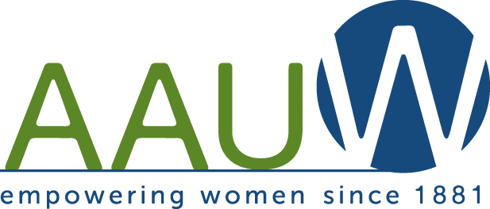

October 2016

Join the Chicago, IL. Inc. Branch in supporting the Legal Advocacy Fund with the Branch’s Ninth Annual NO-DINNER DINNER.

The Legal Advocacy Fund (LAF) works to combat sex discrimination through community and campus outreach programs, a resource library, and online advocacy tools, and various research reports. In collaboration with the Public Policy and Government Relations department, LAF seeks amicus curiae opportunities in cases of discrimination that disadvantage women in the workplace. The AAUW Legal Advocacy Fund has transitioned toward supporting landmark sex discrimination cases that have the potential to make a difference for all women. LAF initiatives include community and campus outreach programs, a resource library and online advocacy tools, a Legal Referral Network, and various research reports. For more information, go to http://aauw.org/act/laf/.

Create a NO-DINNER DINNER, add up your total “bill” and send that amount (or an amount of your choice) as a donation to the Legal Advocacy Fund of AAUW in the enclosed envelope.

With your help, the Legal Advocacy Fund can continue to provide support to women fighting discrimination and inequality.

Empowering Women since 1881.

Ruth Holst
AAUW Chicago, IL Inc. Branch president
Find us on facebook – Chicago branch of AAUW
www.chicago-il.aauw.net
www.aauw-il.aauw.net
www.aauw.org

